
Lab - Install Third-Party Software in Windows

Introduction
In this lab, you will install and remove a third-party software application supplied by your instructor. You will install the Packet Tracer Windows application.

Recommended Equipment
The following equipment is required for this exercise:
 A computer with Windows installed
 A flash drive or CD with the latest Packet Tracer Windows install package

Instructions
Part 1: Installing Third-Party Software
Step 1: Locate the installer.
- Log on to the computer with the Administrator account and use File Explorer to navigate to the folder where the Packet Tracer installer is located. This folder could be on the local hard drive, on an external flash drive or on a CD.
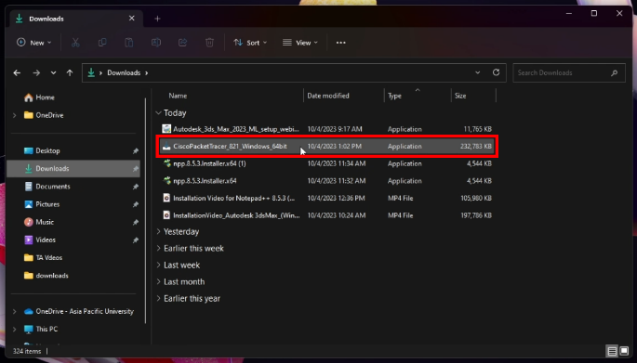
- Unzip the file as necessary. Locate the Packet Tracer application. The filename is in a form similar to PacketTracer_???_Windows_##bit.exe, where ?? is version number and ## is either 32 or 64.
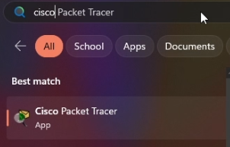

Step 2: Run the Installer to install Packet Tracer.
- Start the installation process of the Packet Tracer application. When prompted, click Yes to allow this app to make changes to your device.
- The License Agreement window opens. Select I accept the agreement, and then click Next.
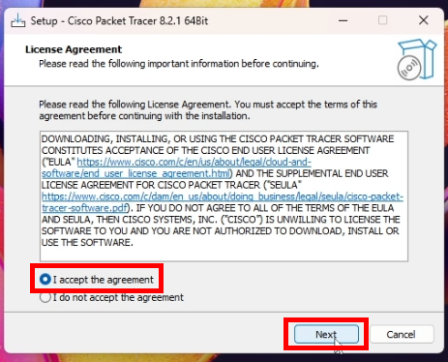
- The Select Destination Location window opens. Keep the default settings and click Next.
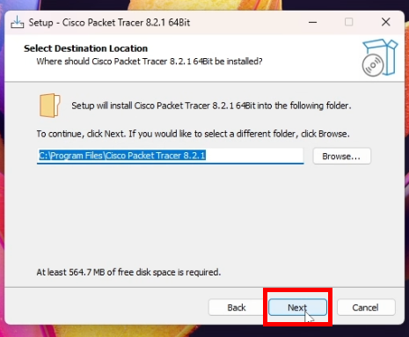
Question:
What is the default installation location for Packet Tracer?
C:\Program Files\Cisco Packet Tracer answers.ere.
- The Select Start Menu Folder window opens. Keep the default settings. Click Next.
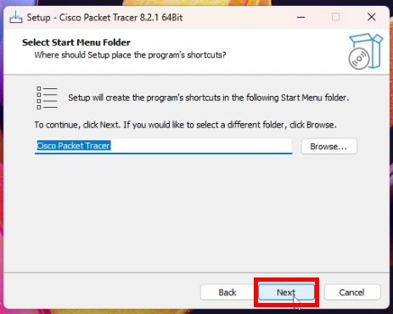
- The Select Additional Tasks window opens. Keep the default settings. Click Next.
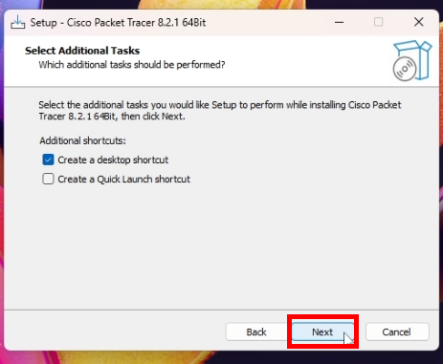
- The Ready to Install window opens. Click Install.
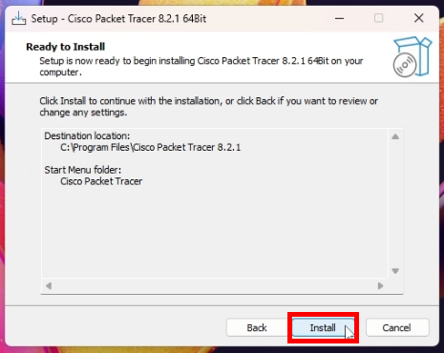
- The Installing progress window opens to show the progress of the installation.
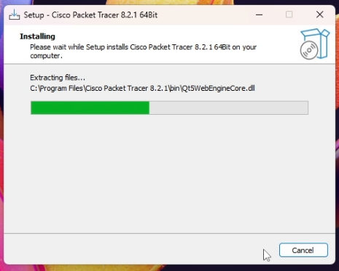
- In the Completing the Cisco Packet Tracer Wizard window, click Finish.
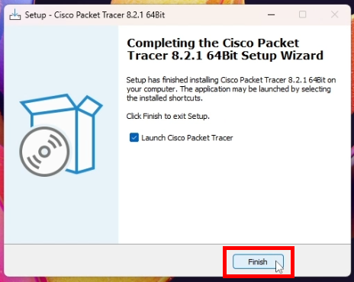
- Be ready to provide your netacad.com credentials when Packet Tracer opens for the first time.

- When Packet Tracer opens, provide your Networking Academy or Skills for All user credentials to continue.
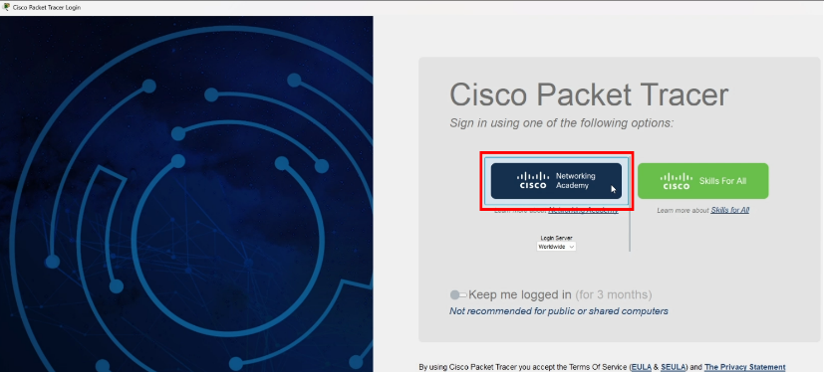
© 2015 - 2022 Cisco and/or its affiliates. All rights reserved. Cisco Public Page 1 of 2
Lab - Install Third-Party Software in Windows

Part 2: Uninstalling Third-Party Software
- To uninstall a program, click Control Panel > Programs and Features. Choose Cisco Packet Tracer in the list and right-click Uninstall.
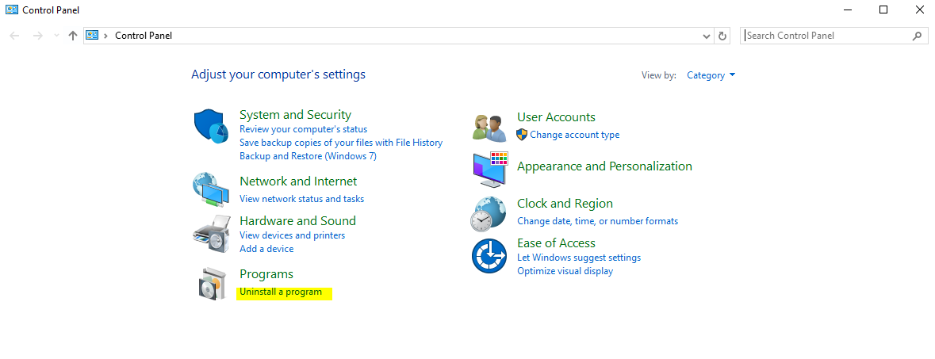
- The Cisco Packet Tracer Uninstall window opens. Click Yes to confirm the removal.
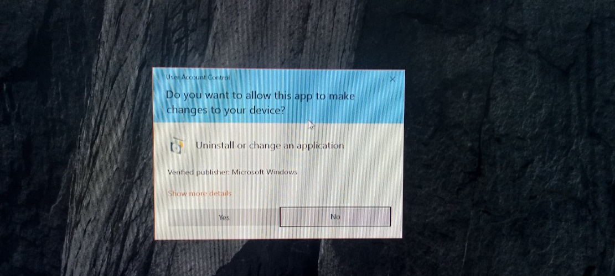
- When the successfully removed from your computer message opens, click OK.
- Verify the application was removed. After the application removal process, the Programs and Features window no longer shows Cisco Packet Tracer in the list. Close all open windows.
- Future activities in this course will require the use of Packet Tracer. Reinstall Packet Tracer.

Reflection Question
Why does Microsoft recommend using Uninstall or change a program to remove an installed application?
When you uninstall a program using this feature, it ensures that all the files and registry entries associated with the application are properly removed from your system.

© 2015 - 2022 Cisco and/or its affiliates. All rights reserved. Cisco Public Page 2 of 2

